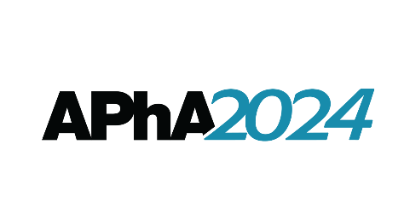
APhA Academy of Student Pharmacists
2024 House of Delegates

REPORT OF THE APhA-ASP RESOLUTIONS COMMITTEE

Presiding: Mark Nagel, 2023-24 APhA-ASP Speaker of the House

2023-24 APhA-ASP Resolutions Committee:
Region 1: Nicole Kayrala Region 5: Stephen Presti
Region 2: Philip Do Region 6: Ashley McKechan
Region 3: Bryan Gomez Region 7: Nicole Larroza
Region 4: Tiffany Preda Region 8: Megan Godfrey

PROPOSED RESOLUTIONS

2024.1 Loan Repayment Eligibility

APhA-ASP calls for pharmacists to be eligible for loan repayment funds in a manner consistent with other healthcare providers.

2024.2 Artificial Intelligence in Healthcare Education

APhA-ASP encourages the judicious use of artificial intelligence in healthcare education with an ethical and human-centered approach that expands the abilities and knowledge of educators and students.

2024.3 Interpretation Services

APhA-ASP supports policies within healthcare settings and legislation that increase the utilization and quality of medical interpretation services to improve patient care and outcomes.

2024.4 Financial Planning Education

APhA-ASP advocates for the inclusion of financial planning education early in the curricula of schools and colleges of pharmacy to equip student pharmacists with the essential knowledge and skills needed to manage personal finances proactively and responsibly.

